Continuous Delivery -2

Creating a Simple Multistaging Release Pipeline

1. By default, Azure pipeline is turned on to Multistage pipeline
2. Step 1 in the document is turned is off because Microsoft Azure is disabled it now

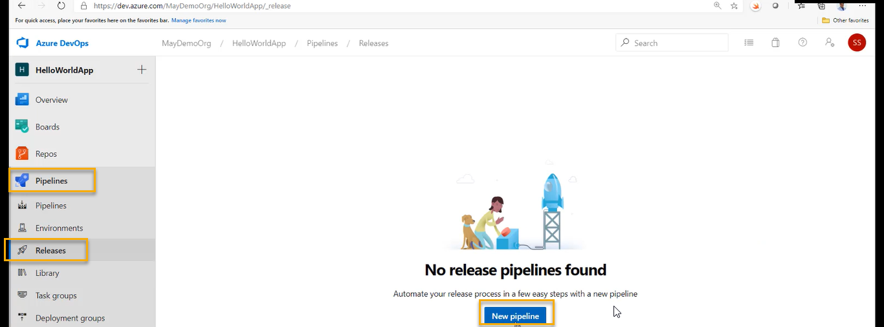

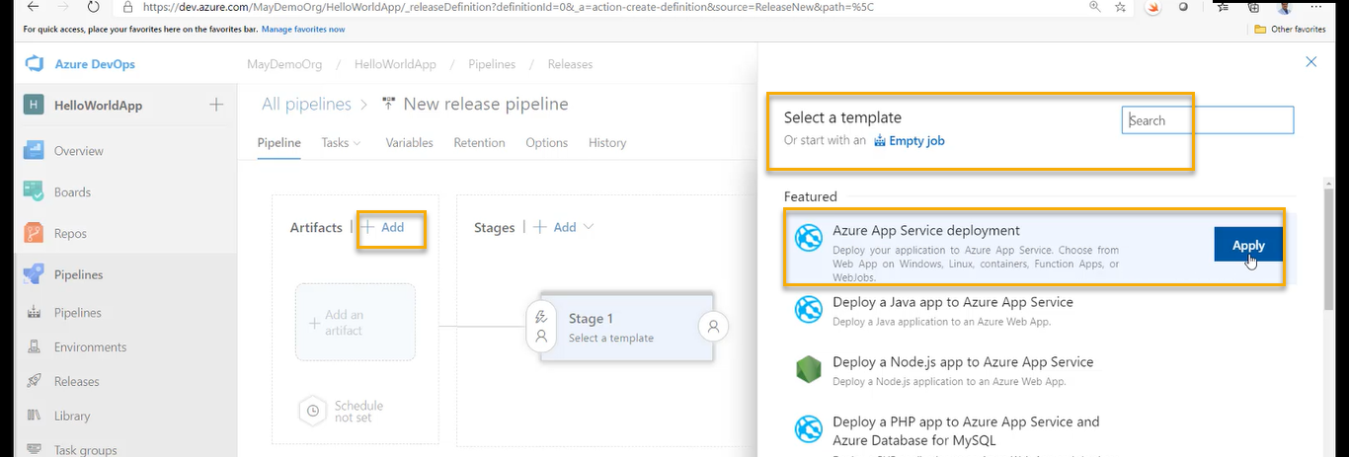

Sorry click on the stages( + Add) with respect to above screenshot

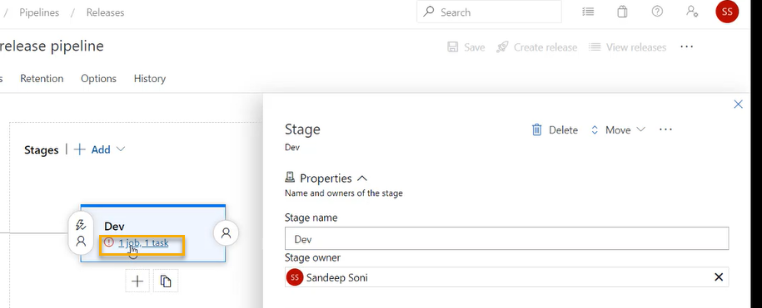

Click 1 job 1task

Under this stage what are the tasks we have we are going to see

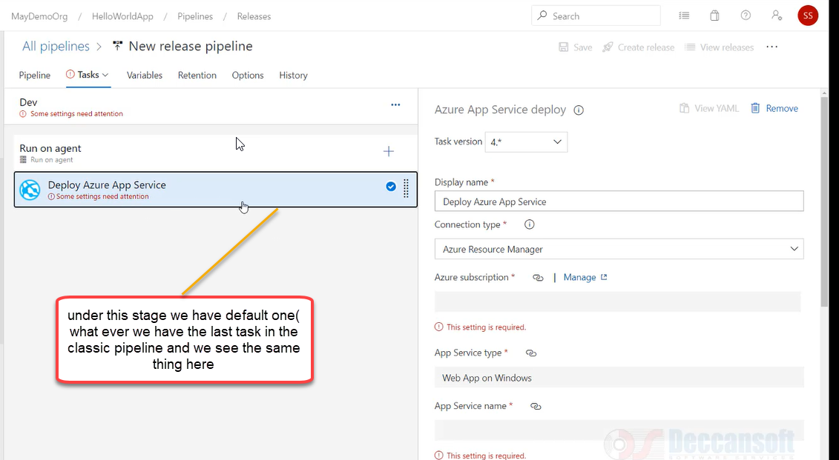

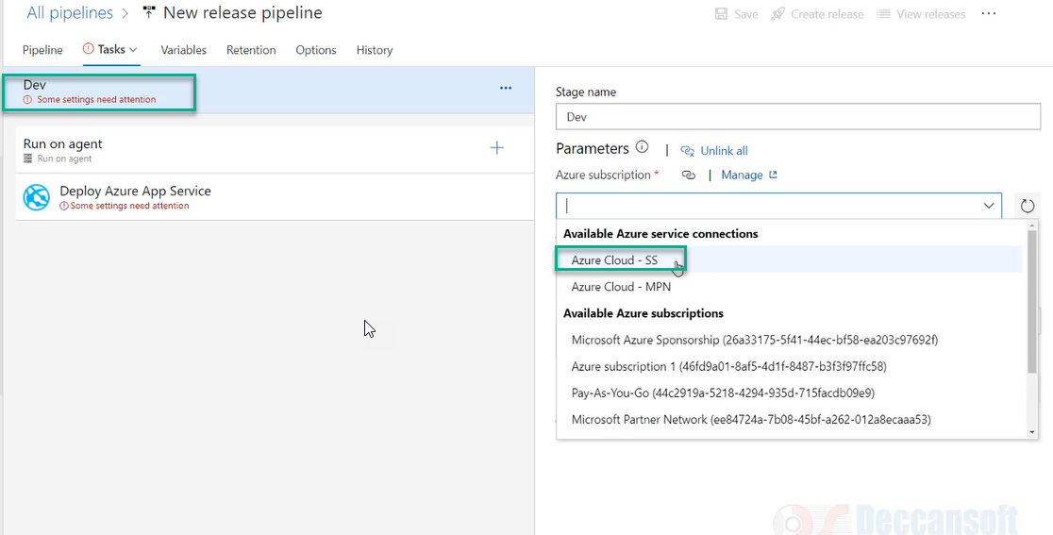

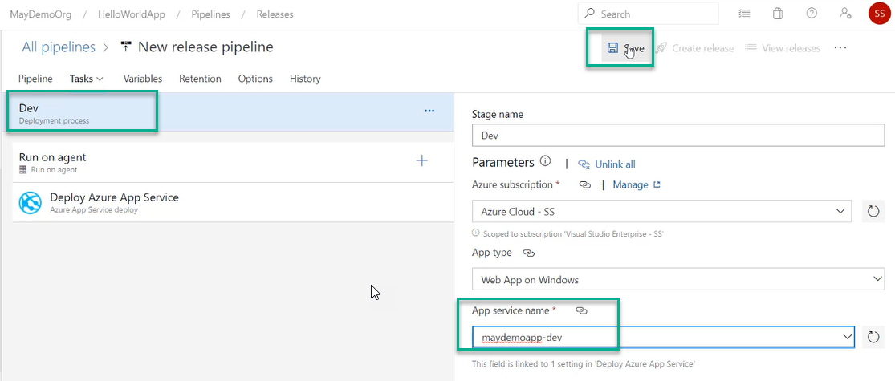

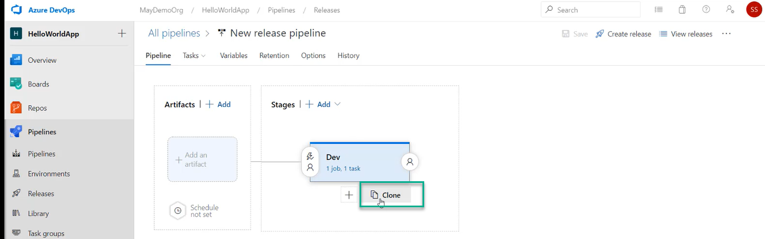

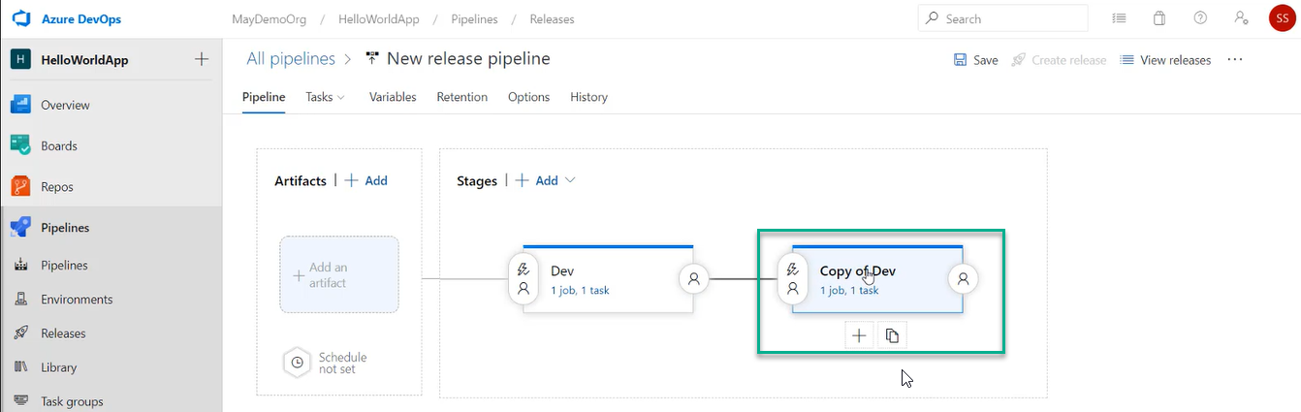

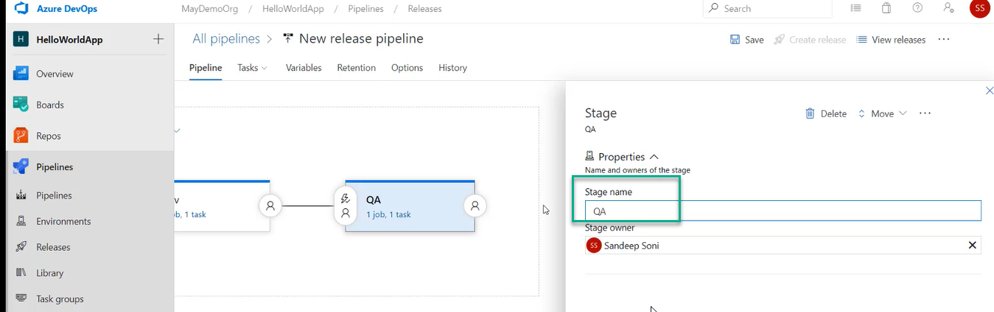

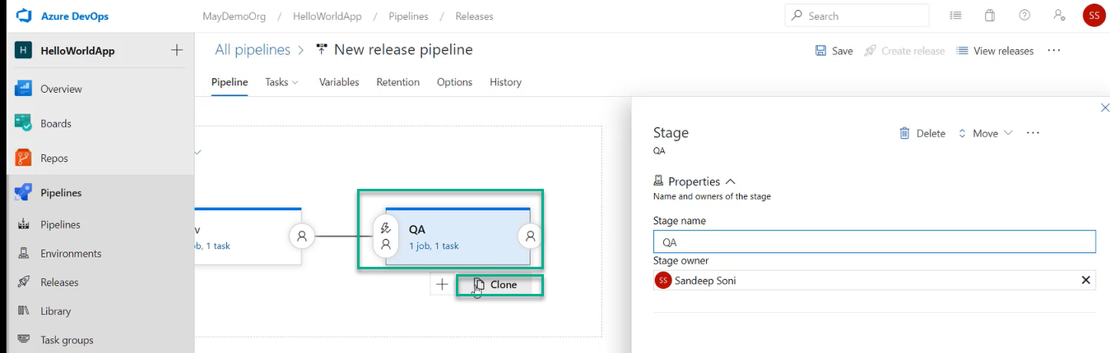

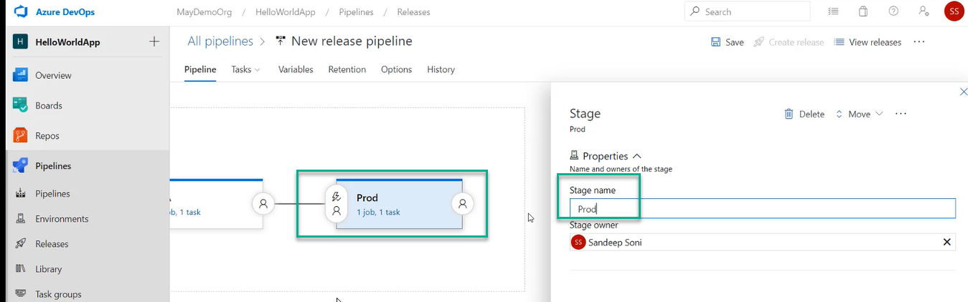

Now change the App service plan for Prod and QA

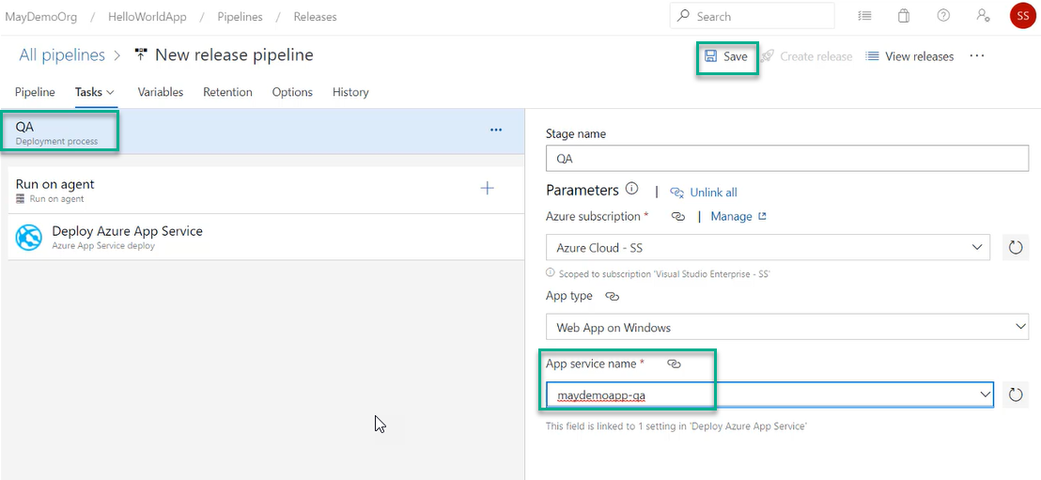

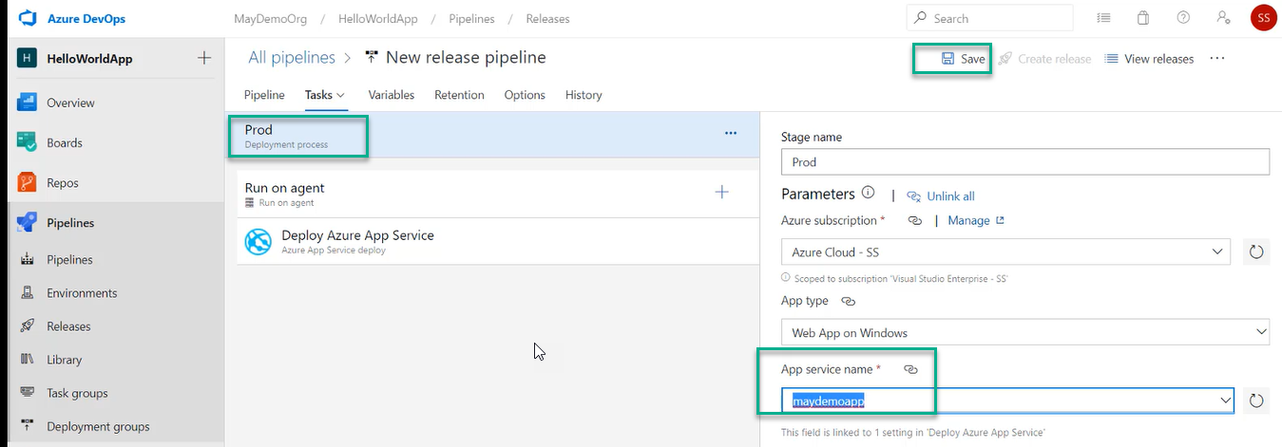

However, we are not publishing in the prod directory. I need a staging facility and if publish in prod the pro server may down temporarily and at the time of copying files from Artifacts to prod machine some files will copy, and some will not be copied

In that situation my production server will be down

We don’t need any down time for prod app server

We need to have run 24x7

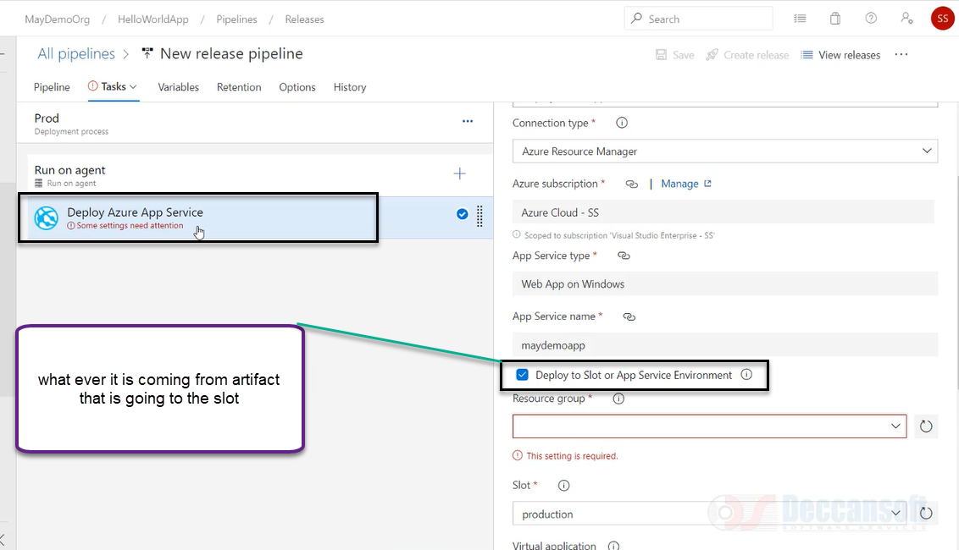

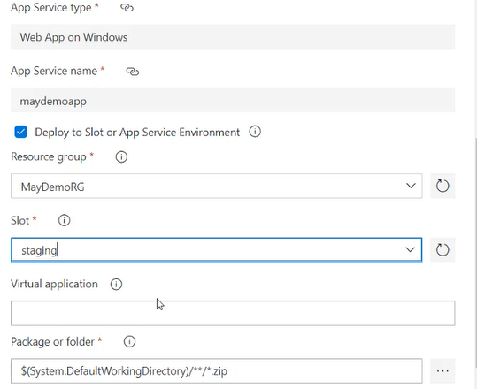

But after slot we will do SWAP with production

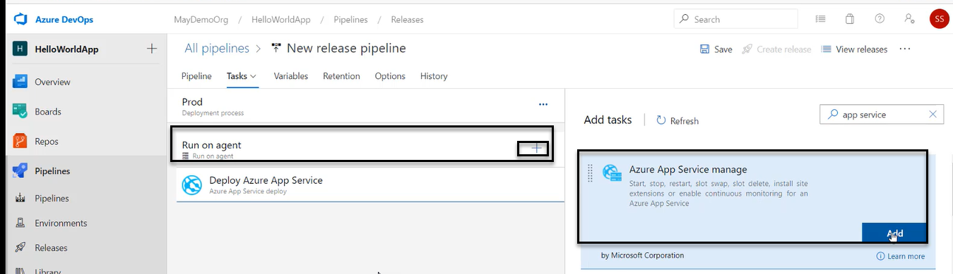

In real time production we may have multiple stages like stage 1, 2

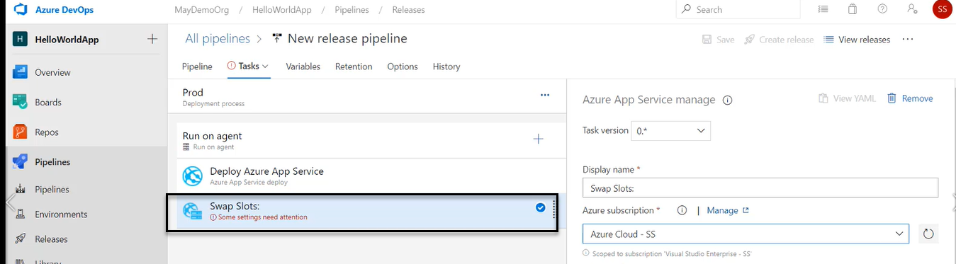

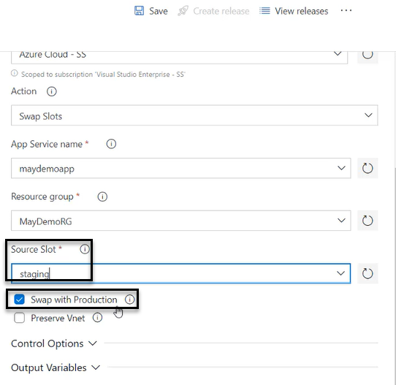

From the artifact I am publishing into staging slot and in staging slot and in staging we will do all analysis and testing and the site is going to load in staging environment

And after it goes to staging environment we need to swap with production. Just URL will be going to SWAP it

And all subsequent requests automatically will go new instances which was staging earlier and suddenly becomes production and there will be Zero down Time

This is also referred as Blue Green deployment

First, we will deploy into Blue which is staging and then swap into Green which is a prod environment

And the click on save as shown in the above screenshot

A pop will come and again click on save

Now we need a source which is called Artifact

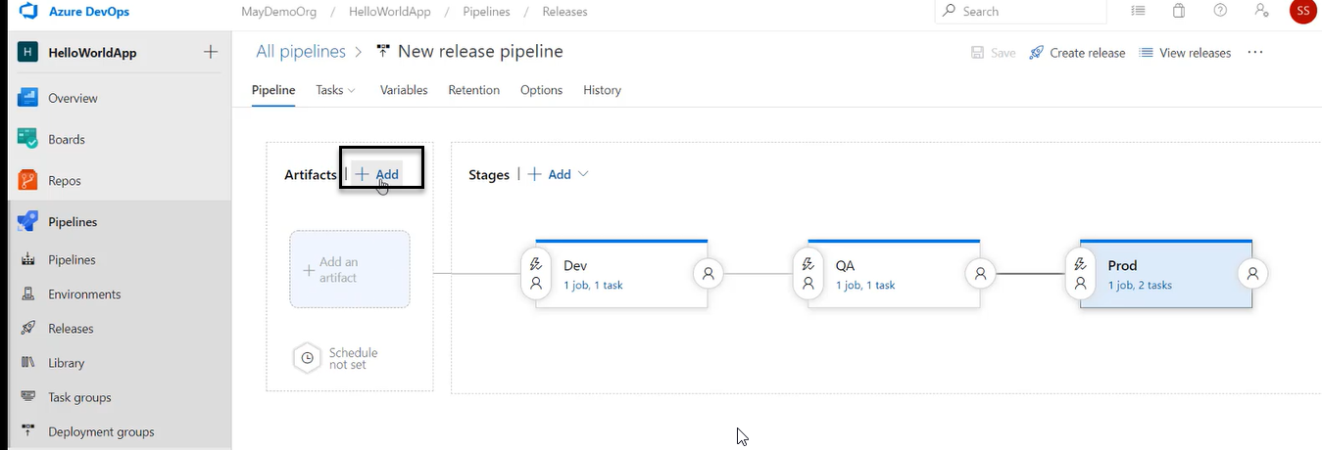

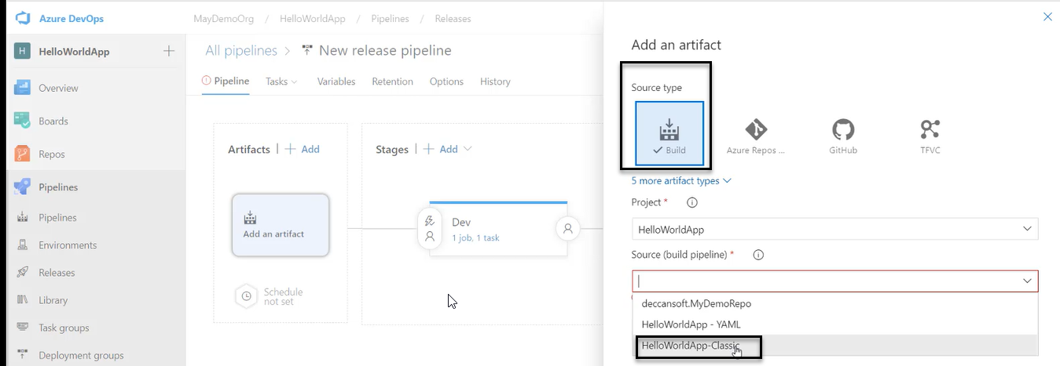

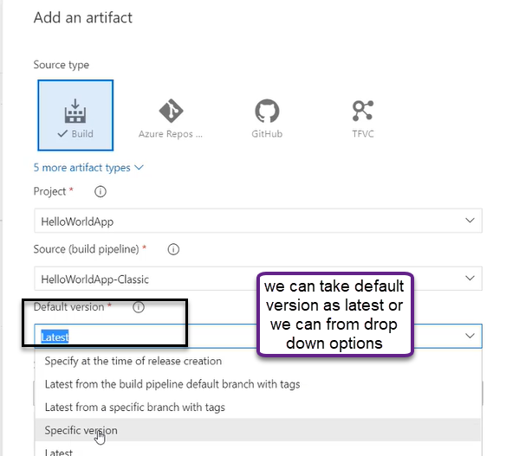

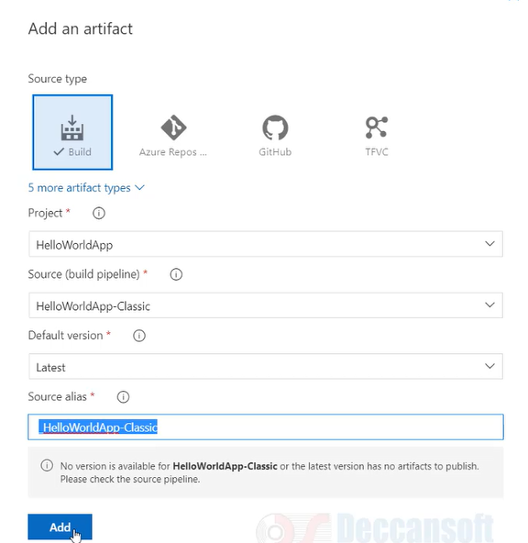

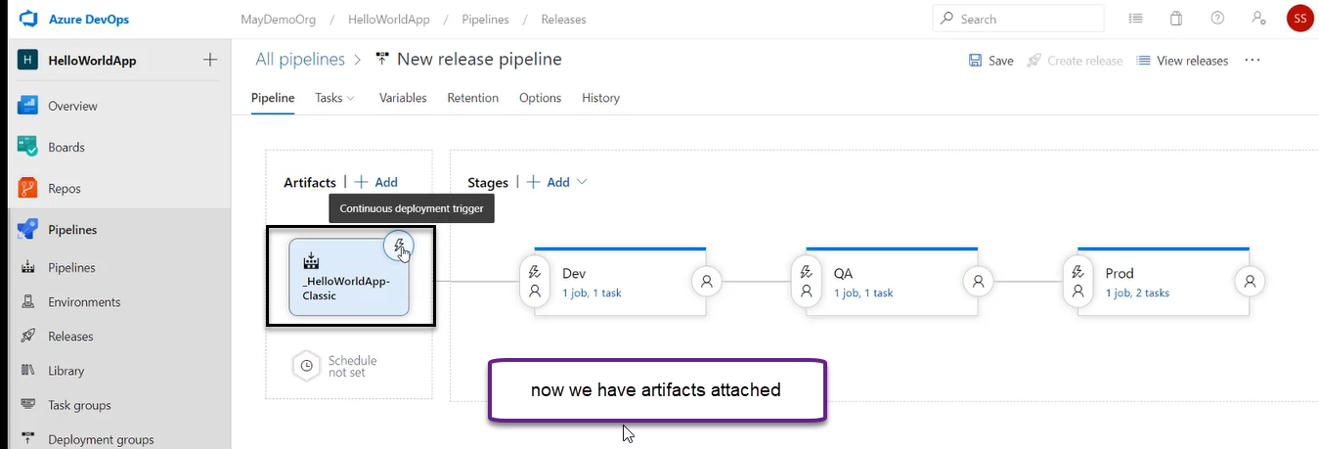

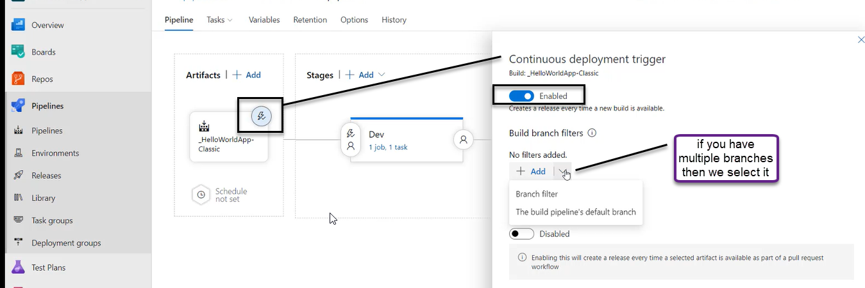

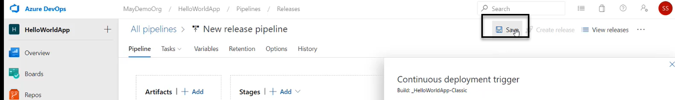

A pop will come and again click on save

We can create a Release pipeline manually and the above set up is release pipeline and when we run the release pipeline it is going to be called as release

We can do it manually by clicking on the Create pipeline

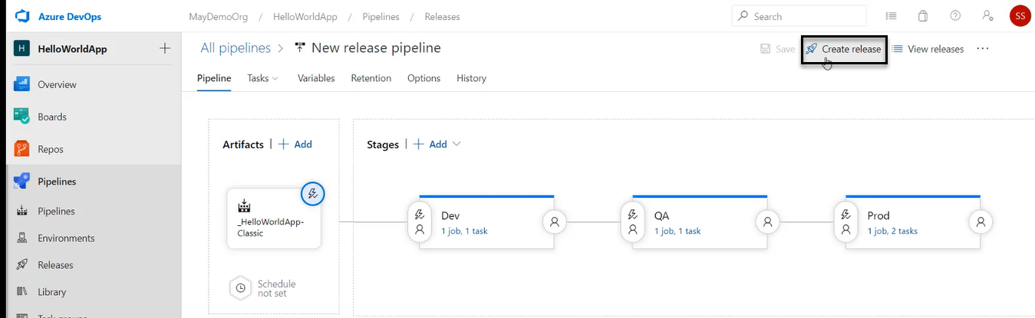

However, we have done continuous deployment trigger

Now go the pipeline where I have connected

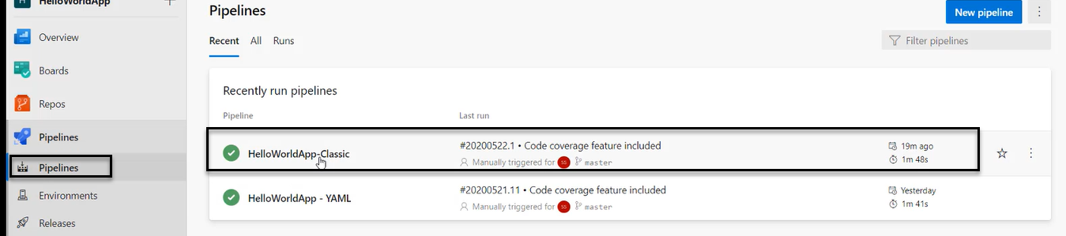

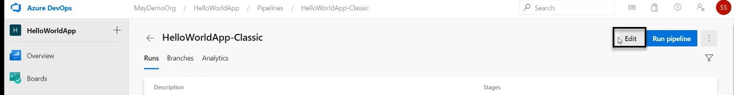

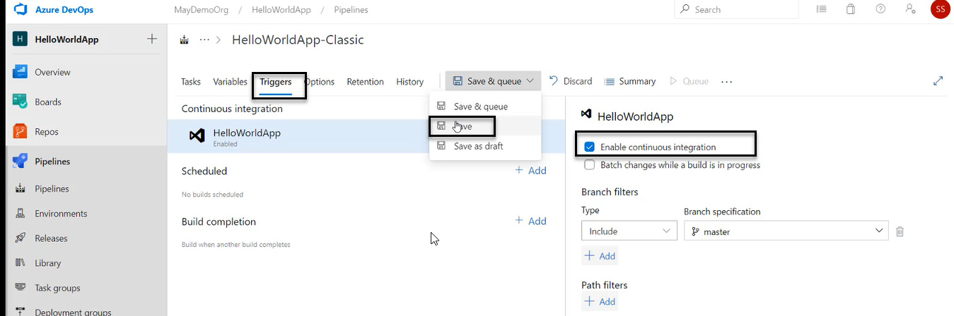

A pop will come and again click on save

Now do some changes to the files and click on commit

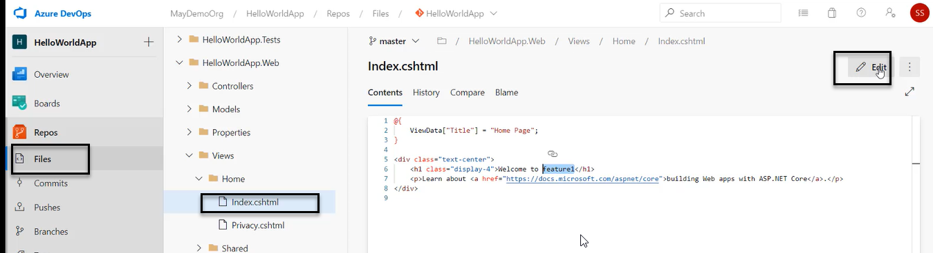

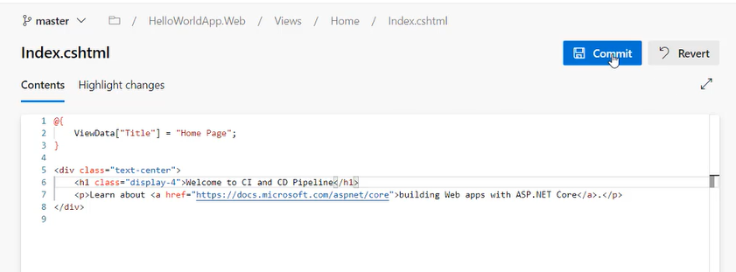

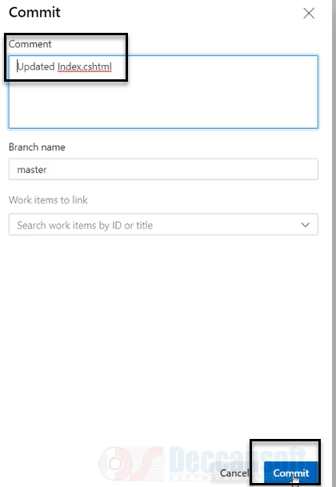

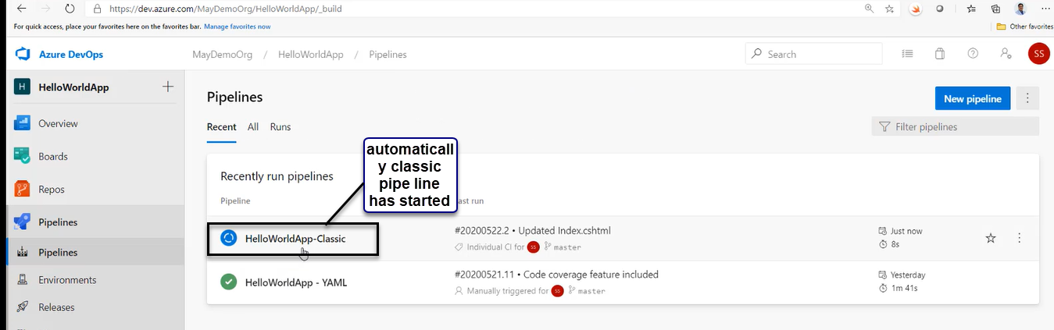

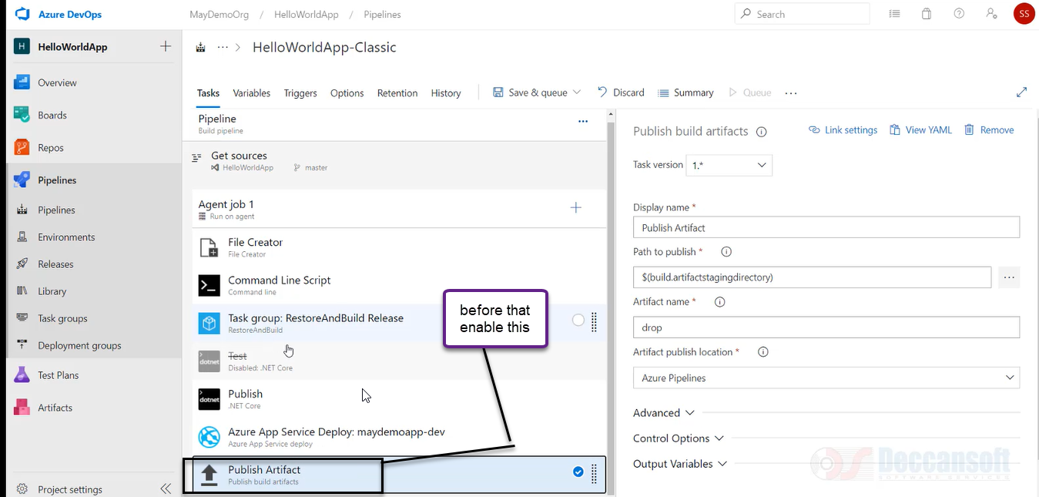

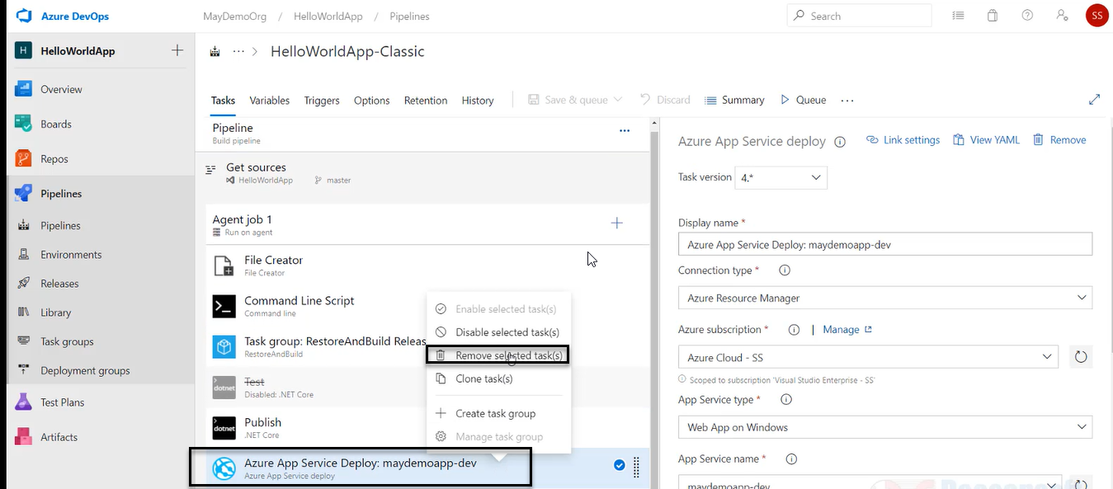

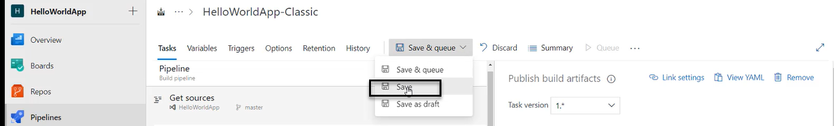

A pop will come and again click on save

We need to again perform the steps by editing the files and do some changes

For time saving click on the below options

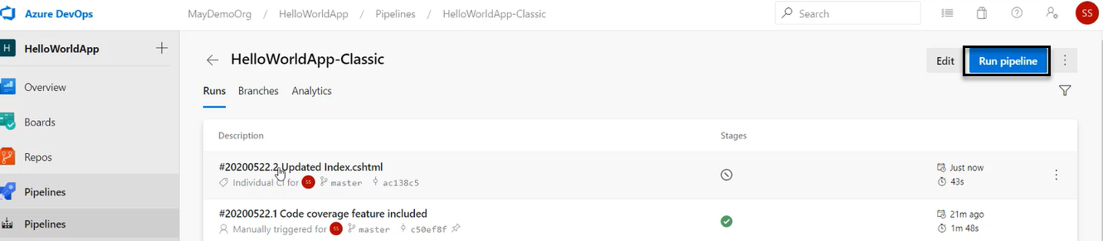

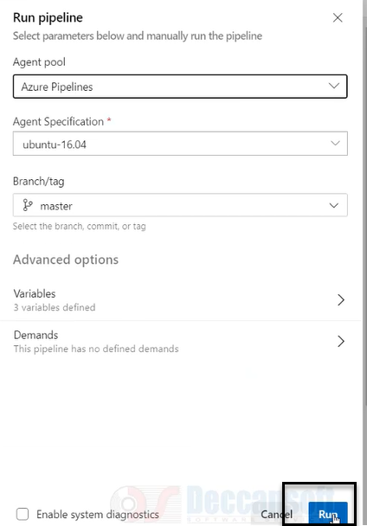

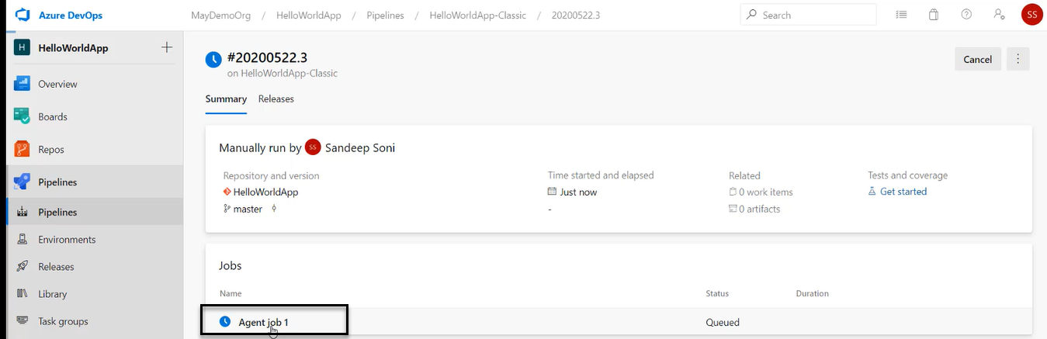

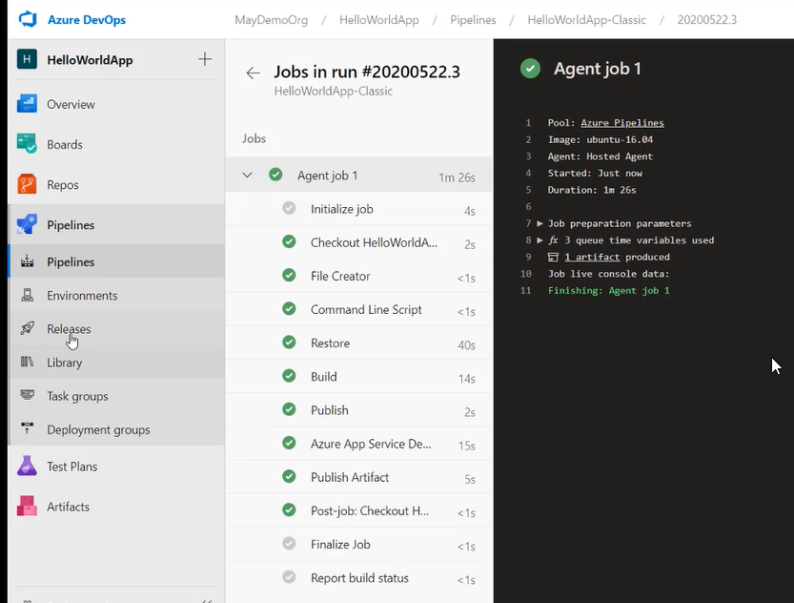

And we see in the Release pipeline has been triggered because of the continuous Release

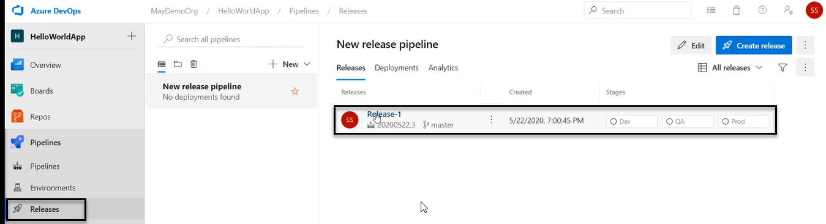

Click on the Release 1

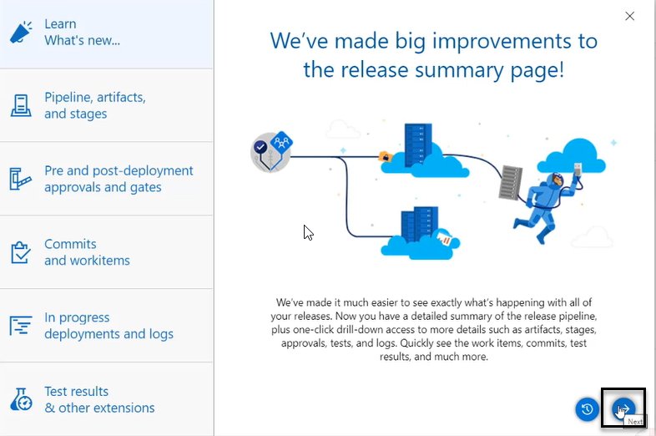

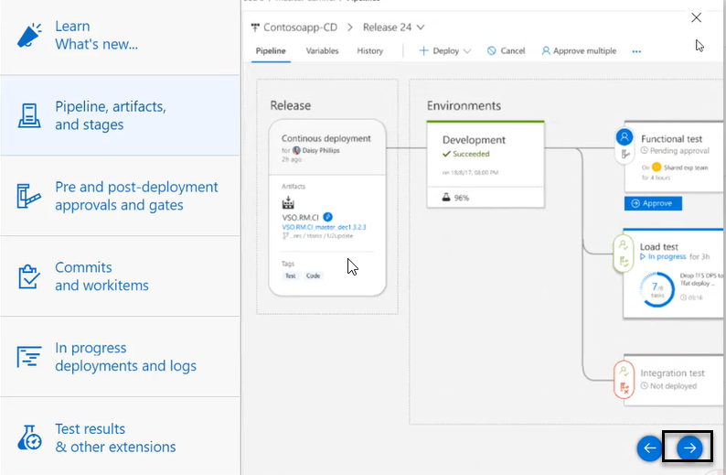

Or we cancel (x) as we see in the above screenshot

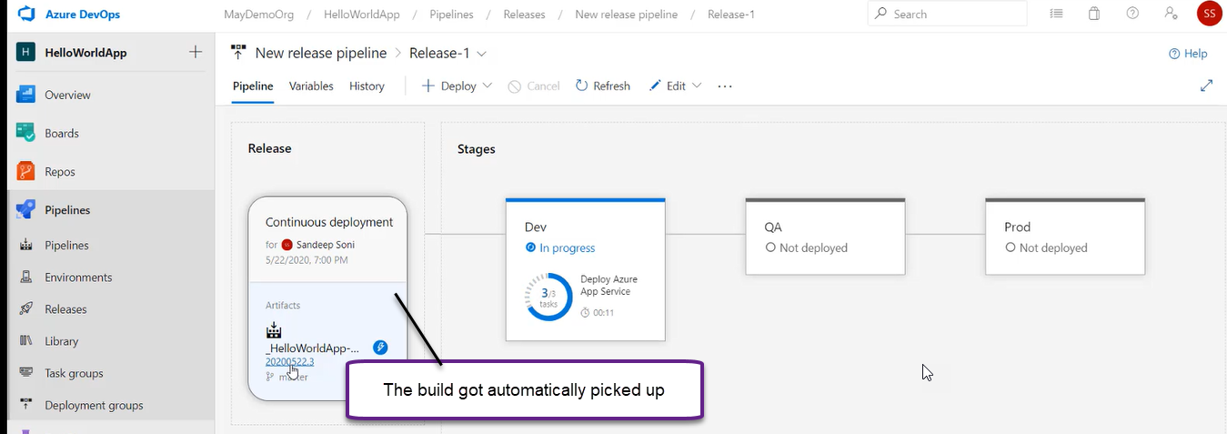

Release pipeline automatically loads the Artifacts

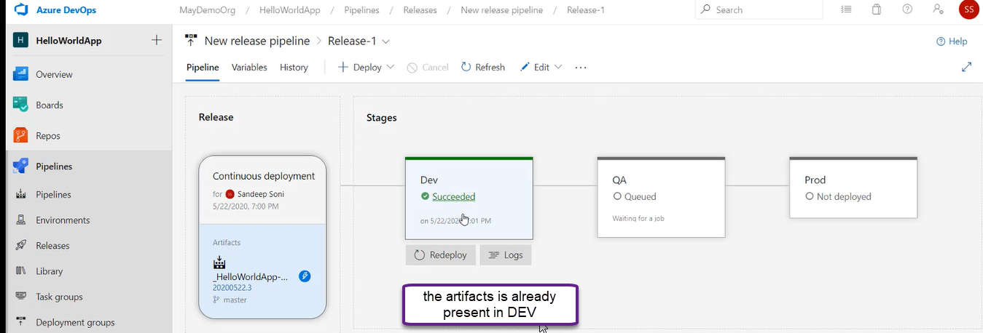

And when we click on URL in DEV app service plan

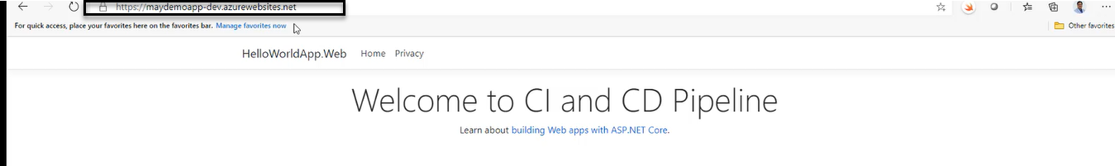

And we see the same for QA, staging and prod

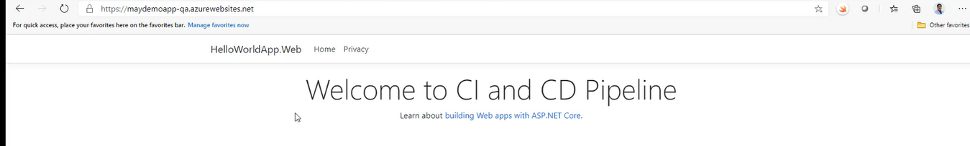

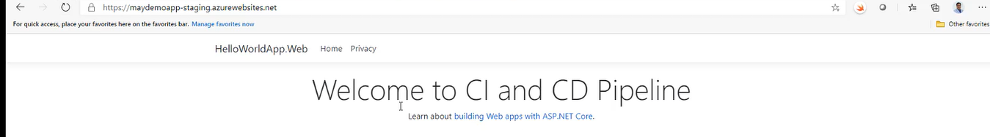

Prod

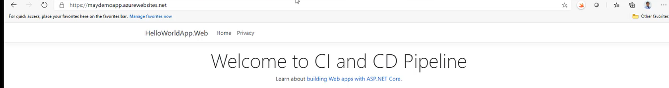

And if we again go to staging, we see the old one because it is already swapped to prod

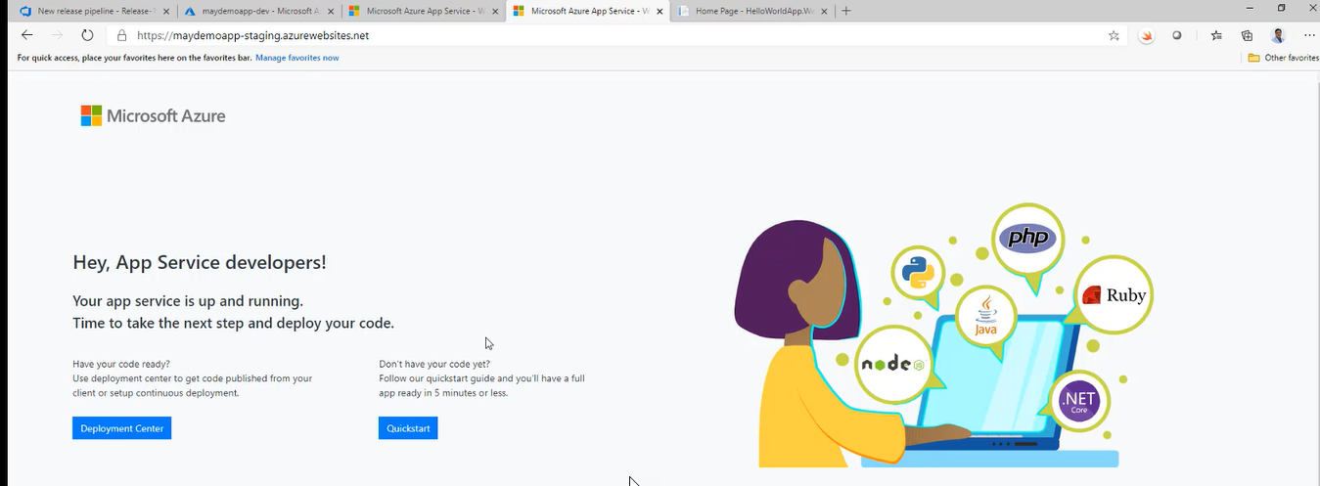

We are NOT going to do in the Real Time Scenarios

Because there will be lot of approvals and there will be gates introduced in between them

Once we deployed in DEV wait for the approval then only go to the QA and gain wait for the approval and then it will go to the prod

So, I how to bring approval process in place

6-Implementing Approval In Release Pipeline

1. If there is any kind of Bug list before it goes into DEV App service I want to make sure that all the bugs are marked as resolved

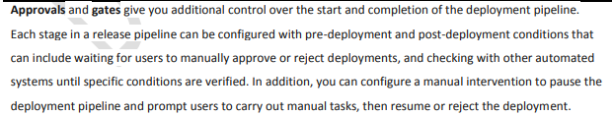

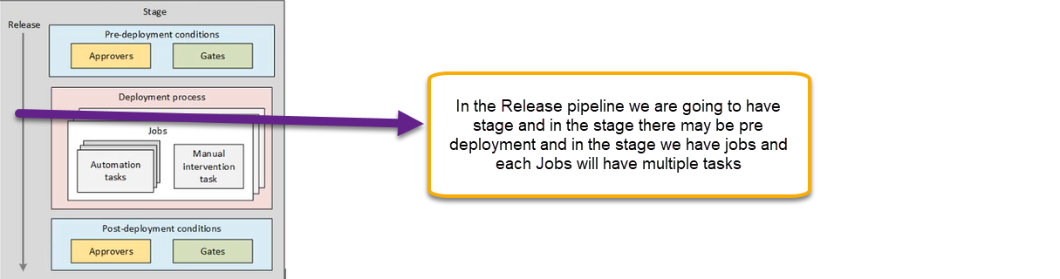

Pipelines > Releases >Select Release Pipeline>Edit

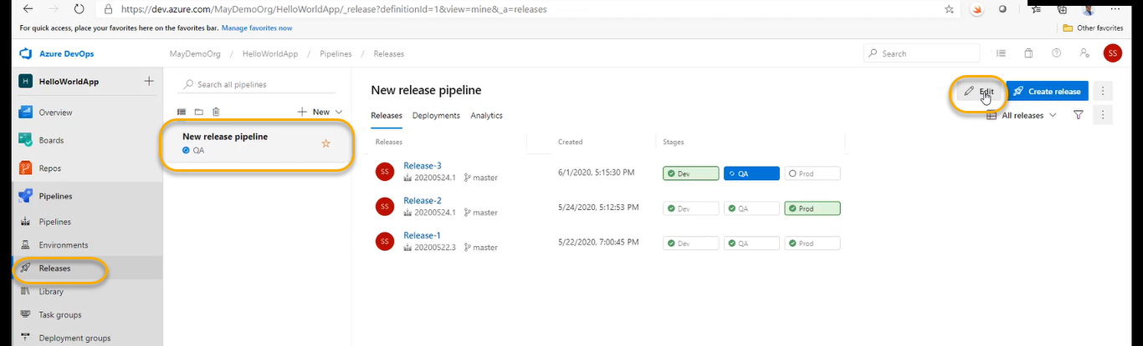

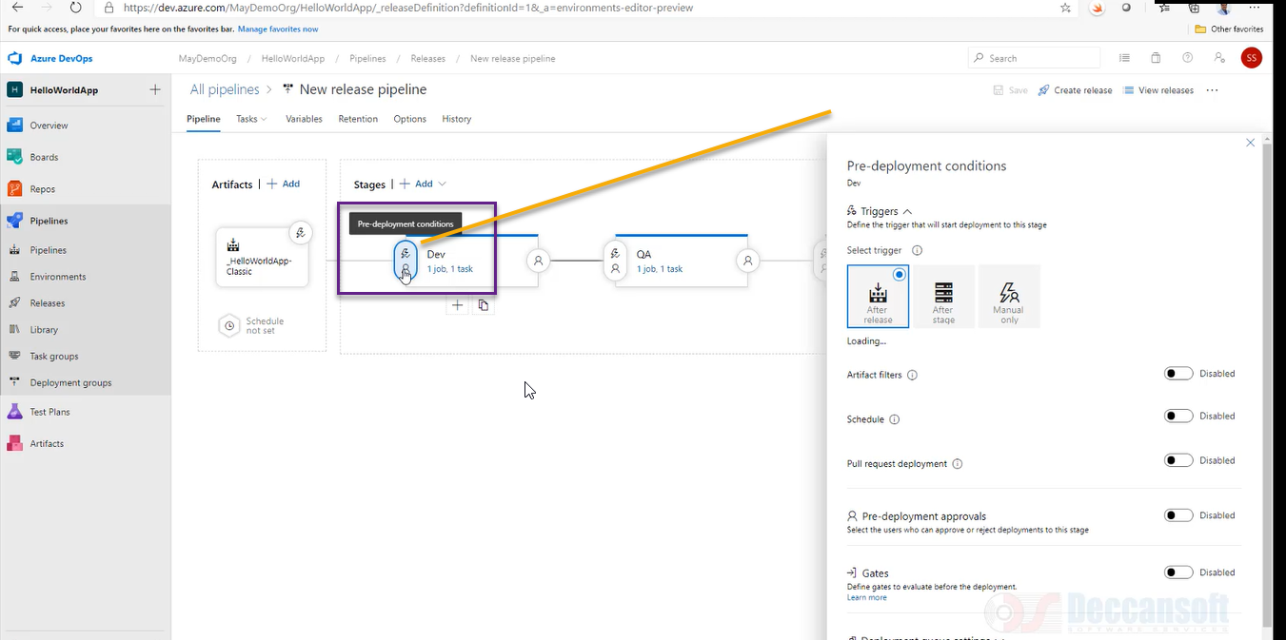

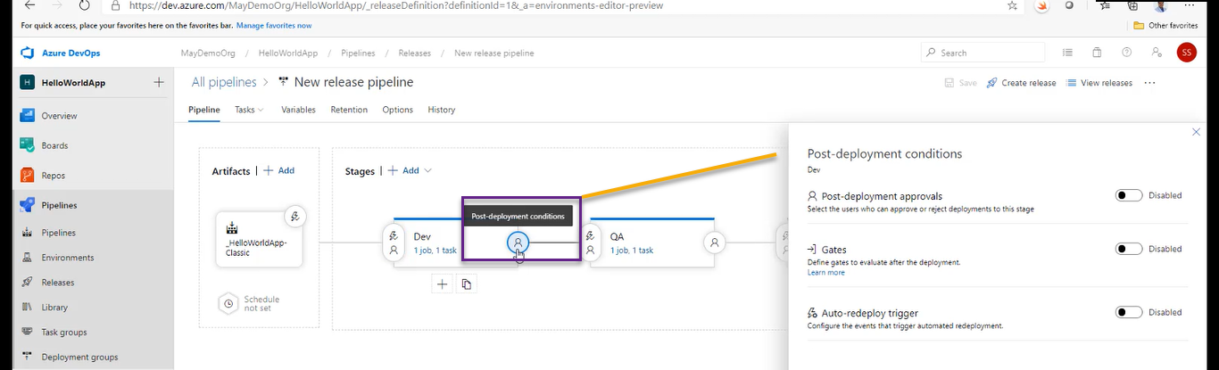

Post deployment does NOT have trigger

And if you click on the Manual for QA

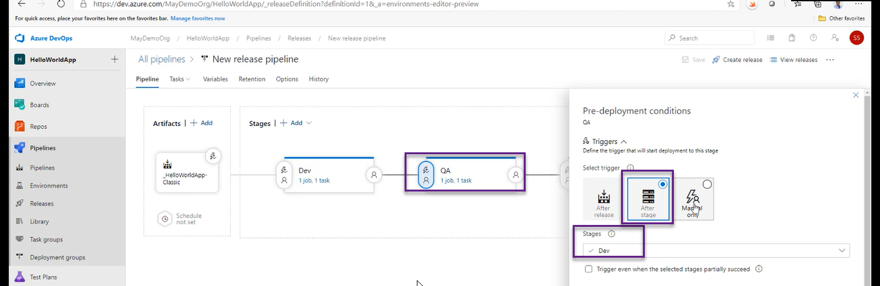



Unless you manual start the DEV will NOT be triggered automatically

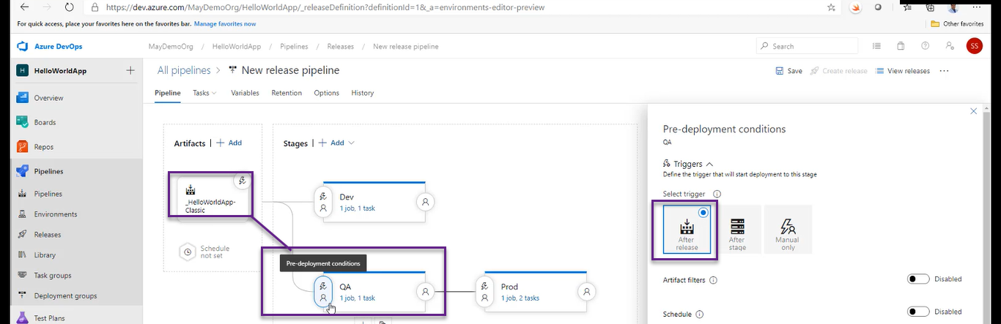

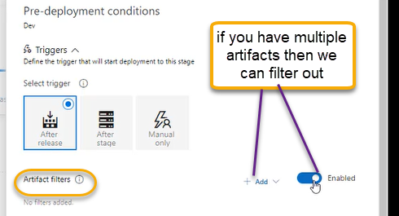

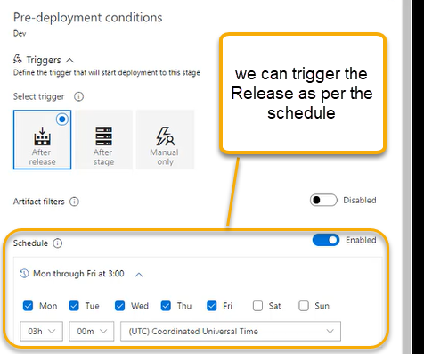

Or based on pull request it should trigger

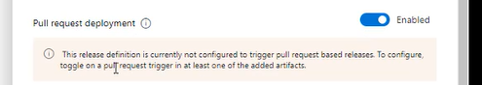

I need approval only if the concerned person will approve and I want to be continue and deploy in Dev environment

With in 30 days approval must be happen if NOT automatically it will Reject

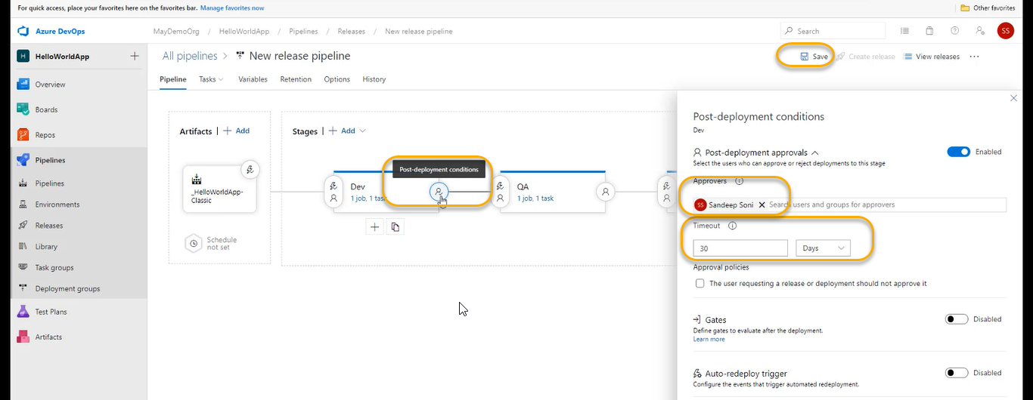

A pop will come and again save it

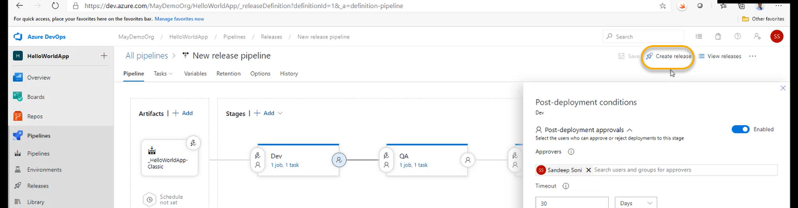

The latest artifacts will move into DEV > QA > Prod

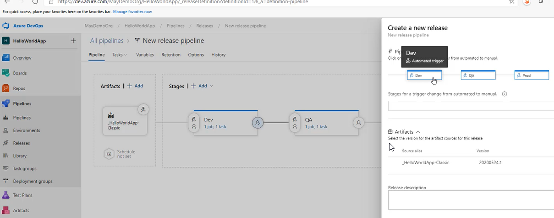

And if you want manual we can click on Blue Box ( Dev) and it will automatically turns into manual

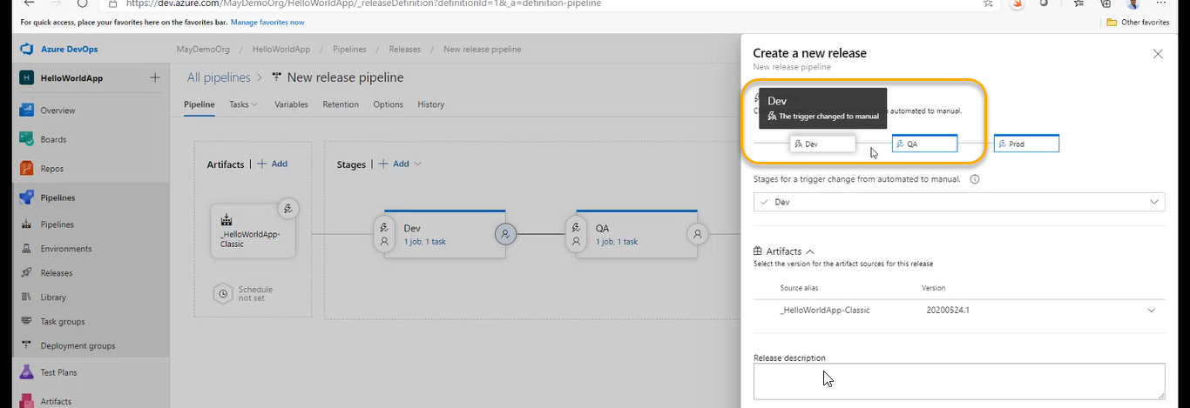

All three becomes manual

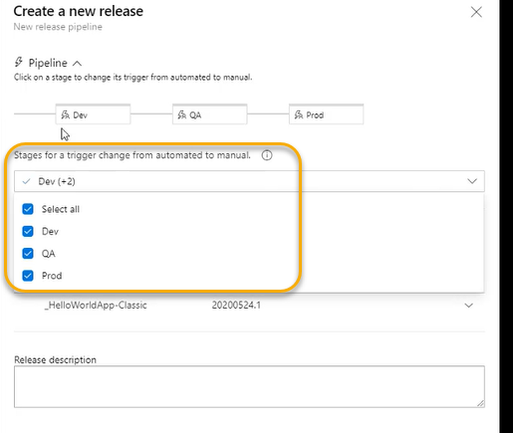

We can change to previous version of Artifact if you want

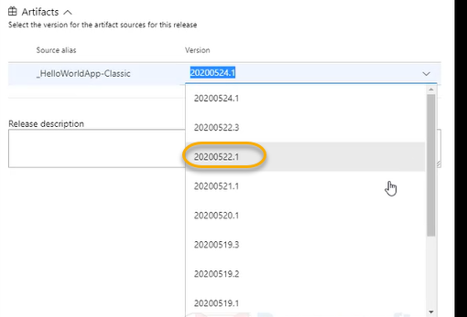

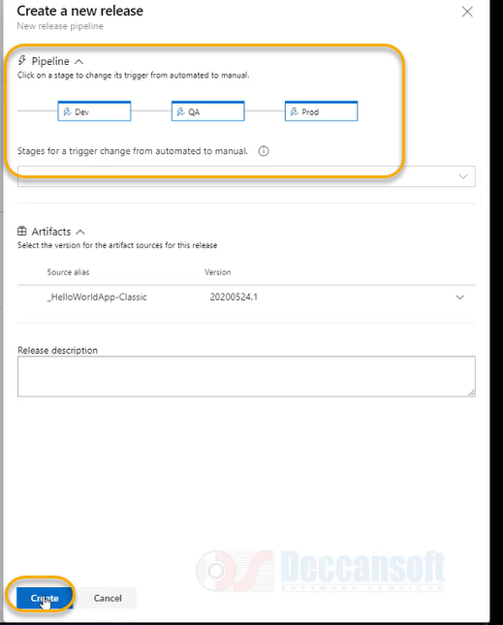

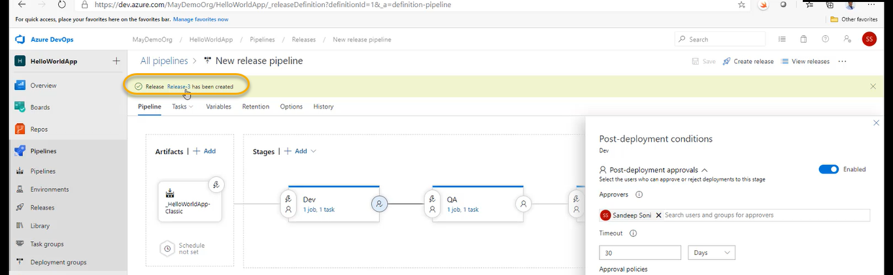

Click on the Release-3 pipeline

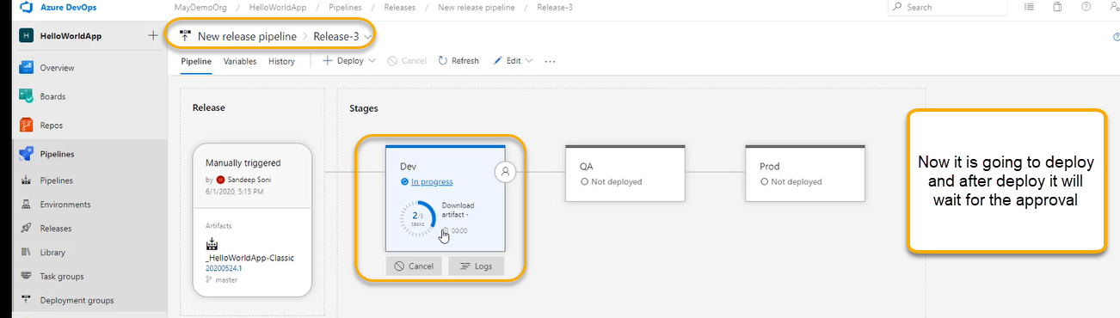

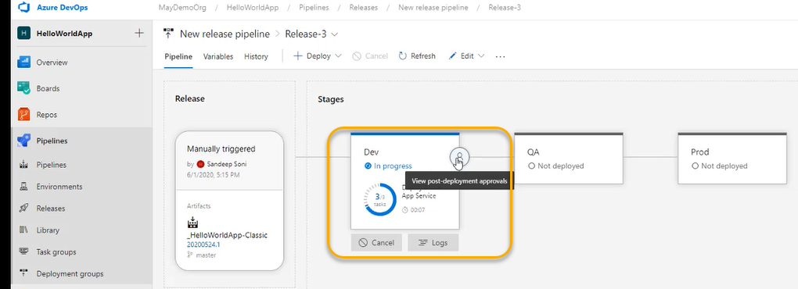

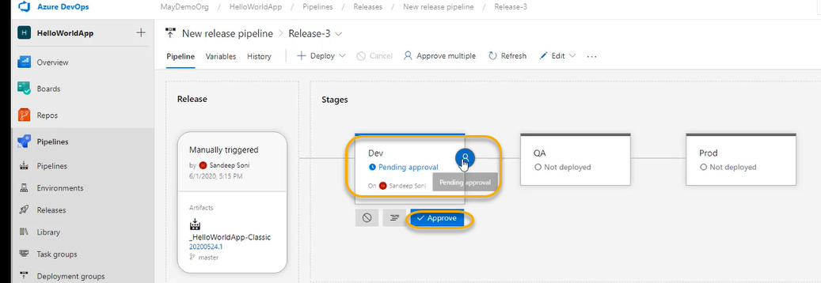

I have given myself to approval, so I am approving

Or some other person will come and approval it

